Advanced Queries And Join

Objectives
At the end of this session, the student will be able to:
- Use JOIN and Sub queries in SELECT statement.

Use ST_EXAM database.
Write the statements to:
- Display the exam marks table. It contains:
The output:
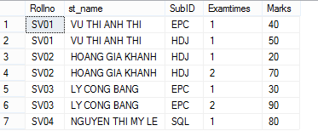
- Display the exam marks table. It contains:
The output is :
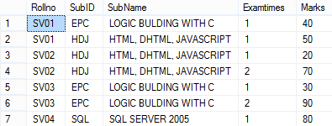
- Display the exam marks table. It contains:
The output is :
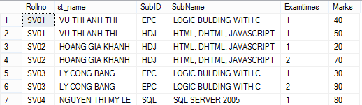
- Insert a record to the STUDENT table:
- Display all of students in the list
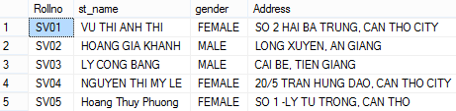
- Display all students who took the exam.
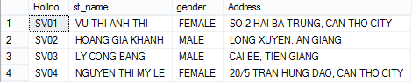
- Display all students who did not take the exam.
- Display Rollno and full name of students who took the ‘HDJ’ examination. (HDJ is the subject id).
- Display information of students who get marks greater than or equal to 80.
- Display information of students who get marks less than the average of all marks.
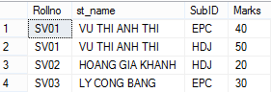
- Create a new table named AptechStudent:
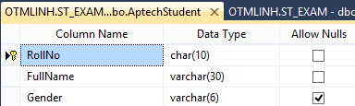
- Insert som records to the AptechStudent table:
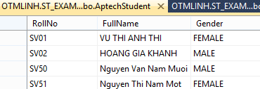
- Select all of students (who are students and aptech students from Student and AptectStudent):
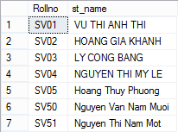
- Display students who are college students but are not aptech student:
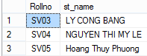
- Display all student who are college students and aptech students.
